STUDY IN KOREA

HALLYM UNIVERSITY

Exchange Program 2015(Spring)

For International Exchange Students

STUDY IN KOREA

Welcome
to Hallym University!

“We are very pleased that you have chosen exchange program at Hallym University and we would like to welcome you to our university and city”

2015 INFORMATION FACT SHEET FOR INTERNATIONAL EXCHANGE PARTNERS AND STUDENTS

Contact information

University Name

Exchange program Office Address

Contact person

Campus information

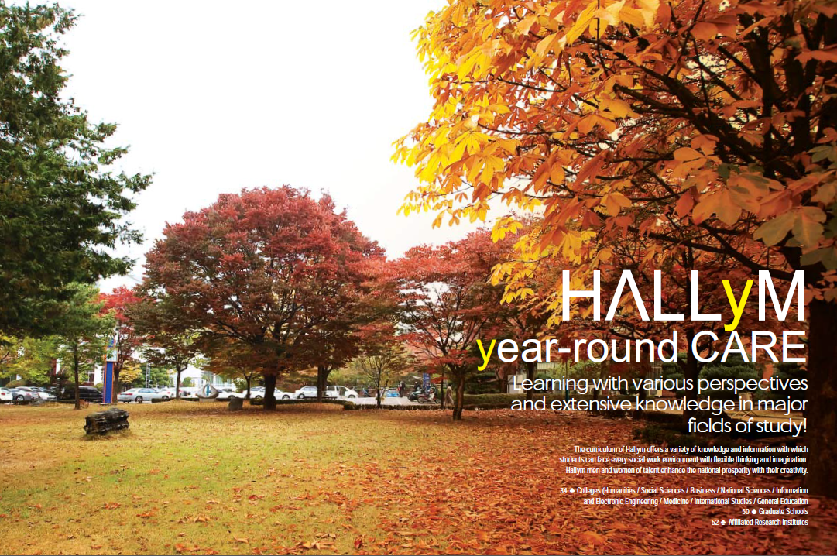
City information
Hallym University

International Affairs Office
1 Hallymdaehak-gil,
Chuncheon, Gangwon-do,
200-702 Korea

Ms. Sujin Pak
iao22@hallym.ac.kr
+82. 33. 248. 1343

Hallym University is a comprehensive higher education institution in Korea with some 9,000 student enrolment. Hallym University ranked 7th in the country and 38th in Asia in the 2009 QS Asia University Rankings. There are currently 8 colleges and 7 graduate schools at Hallym.

Chuncheon is about 50 minutes away from Seoul and is one of the most beautiful and welcoming cities. Chuncheon was voted the best place to live in korea, based on its climate, cost of living, and social conditions like crime rates and employment rates. It was also ranked as the best outdoor city by Ministry of culture, sports & tourism.

STUDY IN KOREA

Exchange Information

Hallym University Semester

Application deadline

Areas of study open for exchange students

Application procedure

How to apply

Application material required

Acceptance package

Student visa

Buddy program

Buddy program
Hallym academic year is divided into 2 semesters.
Spring semester: March – July
Fall semester: September - December

For spring semester: November 15 (previous year)
For fall semester: May 9 (of the same year)

Refer to course list for exchange students (taught in English). Exchange students are allowed to attend all classes offered at Hallym regardless of their majors at their home universities and Hallym.

All students must have an official nomination from their home university and use the application form of Hallym University. Please fill in and print the form by computer. Please provide your email address by which you can be reached for supplementary information during the application process.

Exchange application Self-introduction Dormitory application
Up to date university transcript Copy of passport Two head shot photos

An acceptance package is sent directly to International Office at your home University after the application has been accepted. This includes a letter of acceptance, pre-arrival information and pick-up service request form.

To study in Korea for more than 90 days as a student, you should apply for an exchange student visa (D-2-6) at the Korean consulate near your home. A student visa is issued usually within a few days or a week.

Upon obtaining your original acceptance letter from your international coordinator, you must visit-at the earliest date possible- the nearest Korean consulate with the original acceptance letter and other documents required by the consulate to obtain a student visa. The business registration number of Hallym University is 221-82-05646. You might need this number to apply for a visa.

The program, which runs during the spring, fall semester, is designed to assist new international students with their adjustment to campus, Chuncheon in Korea. The support provided by the Buddy Program is intended to present students with the opportunity to create a social network and community atmosphere through regular social events organized throughout the academic year as well as through individual meetings with their buddies
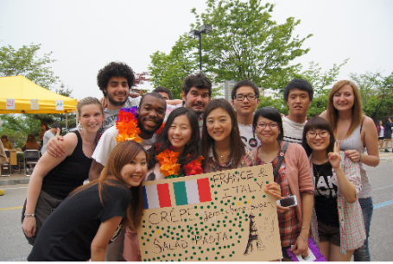
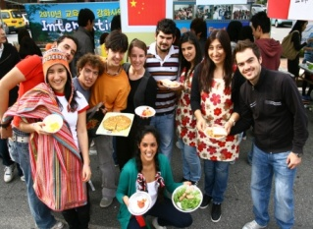
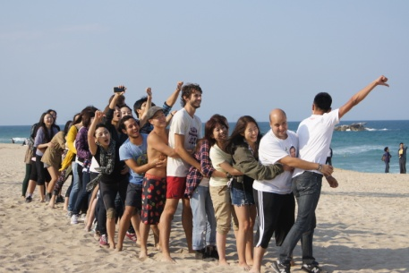

STUDY IN KOREA

Course enrollment

How to choose courses

Average credit per course

Sending transcript

Another information

Budgeting
(Per semester)

Academic Year

Spring semester (2 March – 22 June) | Fall semester (1 September – 22 December)
- Arrival Days 23-25 February  - Orientation 26 February  - Classes begin 2 March  - Classes end 22 June | - Arrival Days 24-26 August  - Orientation 27 August  - Classes begin 1 September  - Classes end 22 December
Summer vacation: 23 June – 30 August | Winter vacation: 23 December – 29 February

In order to make a study plan, please refer to course list information attached in this

In order to make a study plan, please refer to course list information attached in this brochure. This list is only designed to give you a tentative picture of what classes are available at Hallym University, 2015 Spring & Fall semester. The change of the courses might be occurred.

For the Spring semester 2015, in the middle of January 2015, we will send all exchange students the course list with the most up-to-date details on classes (clas
time, description, syllabus, etc.), and will ask you to fill in course request form and
send it back to us for your course enrollment at the beginning of February 2015.
18 credits is the maximum for one semester and you will be able to change your courses after arrival on campus. The International Affairs Office will assist you in course registration. Once you finish your study at Hallym, your grades will be sent to the International Office at your home university within two months.

12 credits - 15 credits

Once you finish your study at Hallym, your grades will be sent to the International Office at your home university within two months.

Students do not have to pay any tuition fees at Hallym University.
However, students have to pay for their accommodation and living expenses.

The type of accommodation offered: On campus dormitory
Housing fee per semester: 480 – 1,200 USD
Costs for food, books, transportation per semester: About 1,300 USD
Other fees per semester: About 1,000 USD for personal expense

STUDY IN KOREA

Instructional Facilities and Support

- Internaitonal Affairs Office: International Affairs Office is a comprehensive International office serving internatioanl students. We deal with visa, acadmic and life counseling, Korean field trips, picnics, insurance matters and assist International students with settling down in Korea.
- Computer & Wireless Resources for Students: There are plenty of internet-ready computers for public use at various spots on campus and free Wi-Fi is available in all of the campus buildings .

- Libraries/ Reading Rooms: Ranked No.1 (Top) library among Korean universities, 2011, the library is a central public research facility and houses all the literature and media made available by the college including around 1,869,138 titles at the moment.
- Academic Counselling Service: The Academic Counselling Service will assist students in matters concerning choice of studies, course contents, and course completion. Students are assigned an academic advisor who they are required to meet with, and discuss appropriate course selections and other academic matters.
- Eating: On campus, the Hallym has four main dining areas: the HU Cafeteria, Students Cafeteria, Fine Restaurant and the College Café. The cafeteria provides three meals a day at reasonable prices to students.
- Public Transportation: The University has a range of public transport options and is well served by subway and bus. Because of its locational advantage, located at the center of the city of Chuncheon, students may easily move around on foot. Also Hallym is just 1 hour away from one of the largest metropolises in the world, Seoul, by subway.
- Health and Safety Notification and Response: The Health and Medical Care Room on campus can provide first-aid treatment for minor problems, and can refer students to facilities on &off campus including Hallym Medical Center for more serious ailments. The Counseling Center on campus can help students under stress deal with culture shock, academic-related issues, and interpersonal relationships. Students are encouraged to visit both facilities whenever they need them. The Hallym University Medical Center (HUMC) is one of the leading medical institutions in South Korea, serving more than 3,600 inpatients, and employing more than 4,600 health care professionals. It incorporates a university affiliated medical school with five major general hospitals and a faculty of 430 members.
- Safety and Emergency Response: In case of an emergency, security guards are on-call 24/7, and members of the International Affairs Office carry emergency cell phones at all times.
- Housing Facilities: Hallym University maintains 8 student dormitories including one apartment complex, all of which can accommodate 2,771 students at the same time. Global Village Apartments, which are self-contained, completely furnished apartments and used for International students dormitory. Students who would like to experience a typical student life should apply for a room at one of the two dormitories. The costs range from 120USD to 280USD per month. In the apartment complex, each room has two beds and such conveniences as a bathroom, an air conditioner, a refridgerator, and internet ports.

